WRES and WDES Action Plans 2022/23
Date: 21st November 2022

Background
1. The Trust WRES (Workforce Race Equality Standard) and WDES (Workforce Disability Equality Standard) Data Reports were discussed at the People Committee (subcommittee of the Trust Board of Directors) on 27th July 2022, and approved by Trust Board of Directors on 4th August 2022. These are available via the Trust extranet.

Trust Equalities & Inclusion Strategy
2. A Trust three-year Equalities & Inclusion Plan has been drafted, and continues to be refined in discussion with key stakeholders. This draws on a range of material, including:-

National
• NHS 2022/23 Priorities & Operational Planning Guidance
• CQC Trust-Wide Well-Led (W3.8)
• NHSE/I Six National Actions for Closing the Gap in Recruitment
• Health Inequalities Leadership Framework – Board Assurance Tool (2022)
• NHSE Equality Delivery System 2022 (August 2022) – ‘Implementation… is a requirement on both NHS commissioners and NHS providers.’
• NHSE ‘Developing an Equality, Diversity & Inclusion Plan for the NHS Workforce’ (draft November 2022)
• NHSE, NMC et al. ‘Combatting racial discrimination against minority ethnic nurses, midwifes & nursing associates’ (November 2022)

NHS Sussex ICB (Integrated Care System/Board)
• Sussex Race Equality Away Day (July 2022)
• Sussex Health & Care ‘Workforce Race Equality Strategy’ (October/November 2022)

UHSussex
• 2022/23 Race Equity A3s
• Staff Networks & EDI Team Inclusion Priorities Planning Sessions (April, July 2022)
• Race Equality Visioning session – Trust Board of Directors (March 2022)
• BDO Equality, Diversity & Inclusion Maturity Assessment framework (draft, April 2022)
• WRES (Workforce Race Equality Standard) & WDES (Workforce Disability Equality Standard) - Data Reports 2022
• Review against The Global Diversity, Equity & Inclusion Benchmarks (GDEIB) Assessment Checklist – September 2022

CQC Well-Led Review
3. The Care Quality Commission (CQC) undertook a Trust-wide well-led inspection in October 2022. Formal feedback to the Trust will be provided in due course, incl. equalities and inclusion.

4. The Trust Board of Directors is due to review the draft EDI Strategy/Plan at a seminar to be held on 8th December 2022. It is envisaged that the plan will be finalised once feedback from the CQC has been received.

Strategy Outline
5. As shown in the graphic below, the draft Equalities & Inclusion Plan focuses on five key domains of activity, each of which supports both the Trust People True North (Staff Engagement), and the other True North domains.

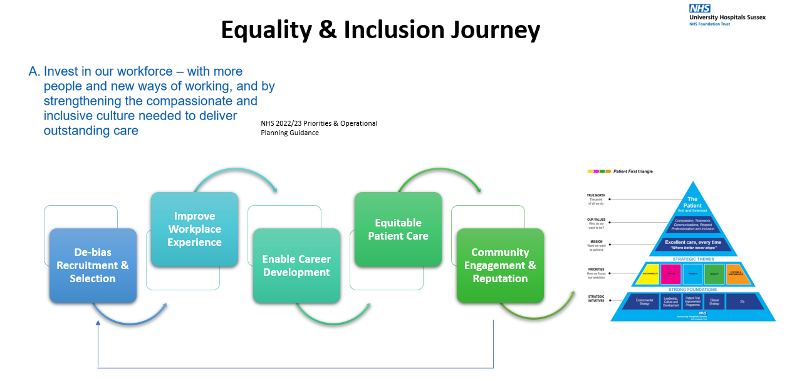

6. Planning has included Staff Networks (Employee Resource Groups), incl. Disability Network, SOAR BAME (Black, Asian & Minority Ethnic) Network and Allies Network, Faith & Belief Forum, LGBTQI+ (Lesbian/Gay, Bi, Trans & Non-Binary, Queer/Questioning and Intersex) Network.

7. Each domain is underpinned by a three-year Action Plan, drawing on the Patient First ‘A3’ (structured problem-solving) methodology.

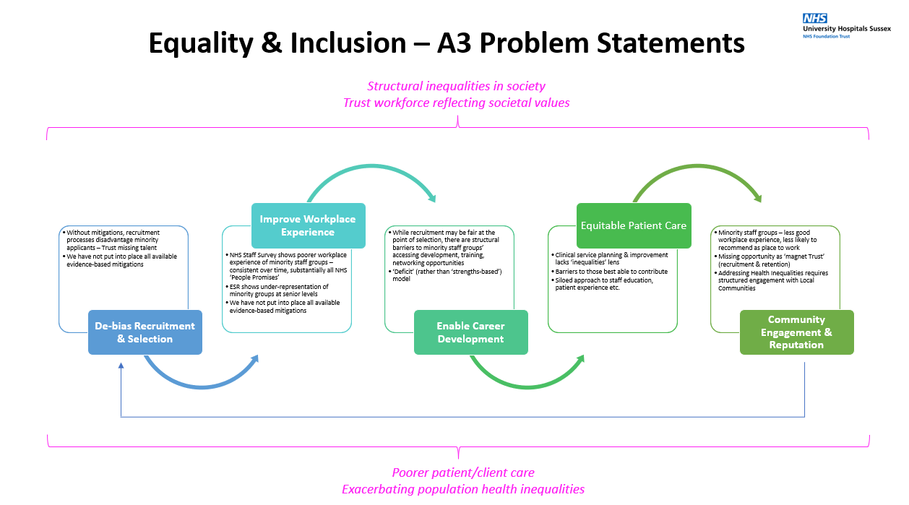

8. Initial areas of focus are likely to include:-

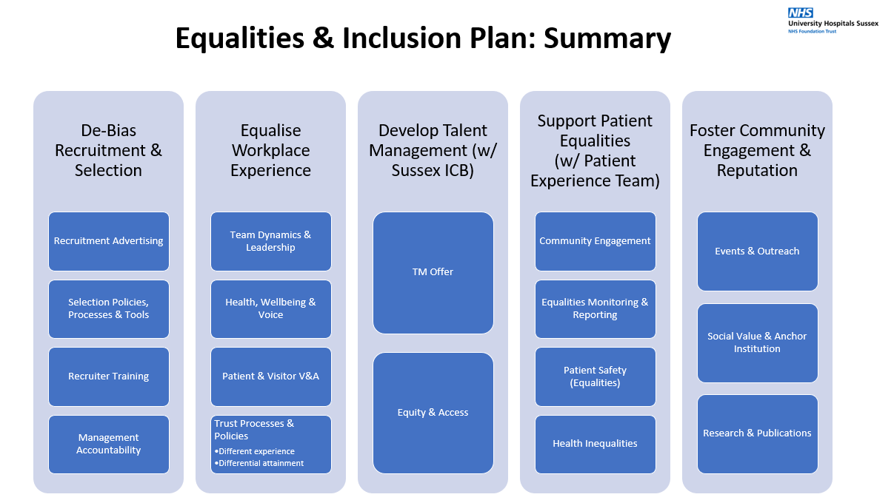

WRES and WDES Action Plans 2022/23
9. The Trust EDI Plan is being constructed to provide both a perspective and integrated approach across all equalities groups, and to enable application of individual lenses (eg. WRES and WDES Action Plans). Publication of the Action Plans will therefore follow approval of the EDI Plan.

