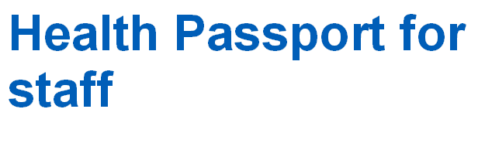

June 2021

Health passport


The individual who owns this document:

Role:

Payroll/employee number:

This is your health passport, which you own and take with you as you move through roles within the NHS. The passport is a place where you can store any information you would like about a disability, long term health condition, mental health issue or learning disability/difficulty.

You can use this passport to tell a new line manager about your health and anything you have in place in the workplace, enabling you to carry out your role. For example, this could be:
- A different start and finish time
- Ways of communicating at work
- More regular breaks at work
- A specific seat at your desk
- Modifications to your desk
- Appointments you regularly need to attend to stay well at work

These changes may be those you need all the time or changes you have to accommodate fluctuations in your health. This passport contains five sections for you to provide details about yourself and your preferences in the workplace:

- Things to know about my health condition or disability
- Things that help me to do my role
- Things to avoid or that make my work more difficult
- Appointments and reviews
- Additional information

You can make changes to the information within the passport when you need to. These should be shared with your line manager and then recorded on the back page of the passport.


Things to know about my health condition or disability

For example:

- Any tasks you need help with or cannot do easily
- Any tasks which may take longer for you to carry out
- Any diagnosis you feel would be helpful for your Line Manager to know
- Any information regarding medication or interventions that you think are relevant to work - these could be fluctuations in conditions or symptoms you would like your Line Manager to be aware of:

Things that help me to do my role


Include information that helps you to access your role and makes your time at work easier. This could be reasonable adjustments you have had to support you, either all the time or as conditions fluctuate.

Time

What times of the day work best for you?



Space

What sort of space do you like working in?

Space

What sort of space do you dislike working in?

Things to avoid or that make my work more difficult

Use this space to say what makes your time at work difficult, such as specific shifts or not having access to certain working arrangements. These could be difficult all the time or as conditions or symptoms fluctuate.

Time

What times of the day do not work for you?



Technology and equipment

What technology and equipment helps you at work?


Communication at work

How do you like to be communicated with at work and given tasks? For example, you may like to be emailed your work tasks to help you remember or prioritise.

Technology and equipment

What do you find difficult to use?

Communicating at work

Are there any methods of communication that are challenging for you or that you cannot use?

Appointments and reviews

Doctor and hospital appointments

Use this space to provide details of recent and upcoming appointments or any regular appointments you may have.

Occupational health

I was last reviewed by Occupational Health on:

Use this space to provide any details about your last Occupational Health appointment. You can also include any review dates or frequency.

Access to work

Use this space to provide details if you have applied to Access to Work for a review or have been provided with a report with details of recommended reasonable adjustments. For example, when did you apply, what recommendations were made, what recommendations have been actioned by your manager or if not, what was the reason(s) why?

Review with your Line Manager

Use this space to provide details of meetings you have with your Line Manager to discuss your health and any reasonable adjustments. For example, when was your last meeting, what did you discuss, and when will you meet again?

Additional information

Use this space to share any information not covered
in the previous sections.

Keep your passport up to date

You can record any changes to your condition or your working environment in the passport.

Please add the date and sign it so both you and your manager can check that you have the latest version.

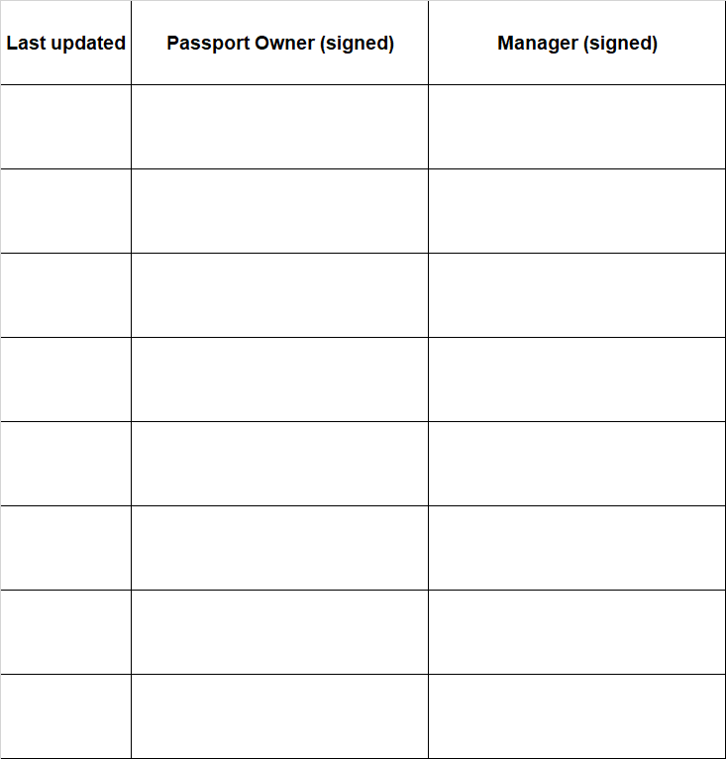

Do you want to update your staff record with your disability information?

Updating your Electronic Staff Record (ESR) allows the Trust to have an accurate picture of the number of staff with disabilities in the workforce.

Having an accurate picture helps make sure the Trust has the appropriate and adequate support staff with disabilities.

If you have access to Self-Service ESR, you can update your record directly by going to the “My Personal Information” section.

There is an online form that gets sent to HR and can be accessed on StaffNet and emailed to: uhsussex.transactionalteam@nhs.net (legacy WSHT) and uhsussex.equality@nhs.net (legacy BSUH).

Anonymised health passport returns

Please ensure that an anonymous Returns Form is completed for each new or amended/reviewed passport.

The Returns Form can be found on StaffNet (legacy WSHT) and on https://nww.bsuh.nhs.uk/working-here/equality-diversity-and-human-rights/workforce-declaration-project/ (legacy BSUH).

The Return Form will be emailed automatically to uhsussex.western.equality@nhs.net (legacy WSHT) by clicking the button on the form named “click here to send form by email” and uhsussex.equality@nhs.net (legacy BSUH).

