To: Trust Board
Date of Meeting: 26th April 2018 | Agenda Item: 10

Title
Provider Self-Certification
Responsible Executive Director
Marianne Griffiths, Chief Executive
Prepared by
Brian Courtney, Interim Director of Corporate Governance
Status
Disclosable
Summary of Proposal
The Board of Directors is asked to Approve that the attached statement (Annex 1), which are required by NHS Improvement under the NHS Provider Licence, Risk Assessment Framework and the Health and Social Care Act 2012.
Implications for Quality of Care
No direct implications.
Link to Strategic Objectives/Board Assurance Framework
Good Corporate Governance standards.
Financial Implications
No direct implications.
Human Resource Implications
N/A
Recommendation
The Board is asked to APPROVE that the self-certifications are made and signed by the Chair and Chief Executive.
Communication and Consultation
N/A
Appendix
1. Provider Self-Certification FTG6(3) and FT4(8)
2. Certificate on Training of Governors

BOARD CORPORATE GOVERNANCE STATEMENT – April 2017

1.0 | PURPOSE AND RECOMMENDATION  The Board of Directors is asked to approve the signing of the following certificates:  - Licence Condition 6 self-certification (Annex 1)  The Board must certify that it has taken all necessary precautions to comply with the Trust Provider Licence, the NHS Act and NHS Constitution. Confirmation statements are provided but further detail is captured within the Annual Governance Statement as part of the Trust Annual Report.  - Certificate on Training of Governors (Annex 2)  Confirmation statements are not required for this self-certification. However, the development of Governors forms part of the Annual Report, the content for this section has been agreed by the Lead Governor.
2.0 | SUMMARY AND CONCLUSION  The Board is asked to APPROVE that the self-certifications are made and signed by the Chair and Chief Executive.

Annex 1
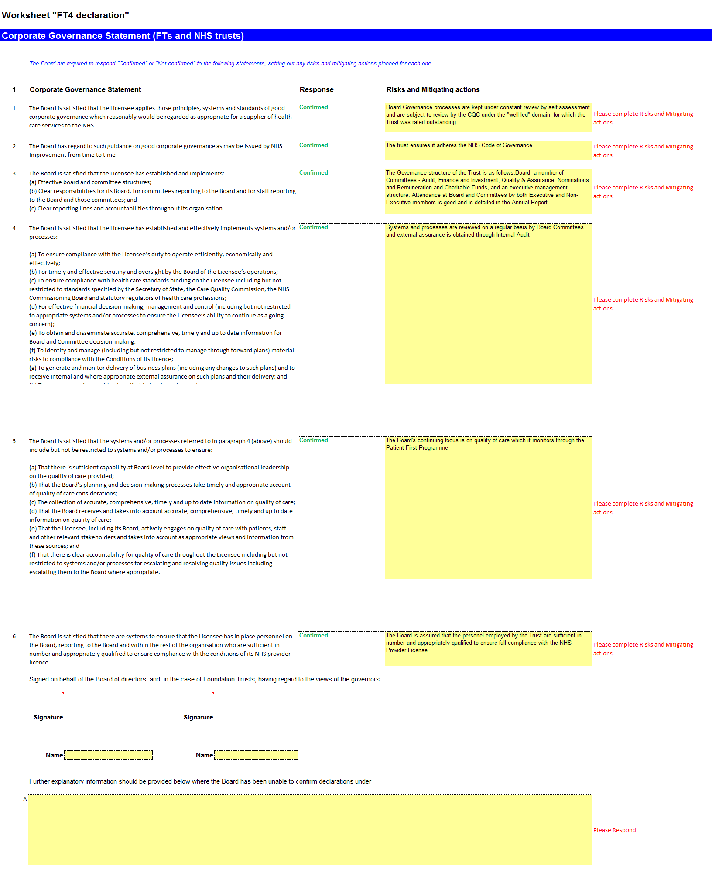
Annex 2
