Health and Wellbeing Passport

Contents
Contents 2
Health and wellbeing passport 3
Things to know about my health condition or disability 4
Things that help me to do my role 5
Appointments and reviews 7
Additional information 9
Keep your passport up-to-date 10
Do you want to update your staff record with your disability information? 11
Anonymised health passport returns 11
Reasonable adjustments 12

2

Health and wellbeing passport
HEALTH AND
WELLBEING
PASSPORT

Name:
How to pronounce my name:
Pronouns:
Role:

This health passport belongs to you as you move through roles within the NHS.
Use it to store information about a disability, long-term health condition, mental health issue, or learning disability/difficulty.
You can use this passport to tell a new line manager about your health, and anything you have in place in the workplace that enables you to carry out your role.
For example, this could be:
- a different start and finish time
- ways of communicating at work
- more regular breaks at work
- a specific seat at your desk
- modifications to your desk
- any appointments you regularly need to attend to stay well at work

These changes may be those you need all the time or changes you have in place to accommodate fluctuations in your health.
This passport contains four sections for you to provide details about yourself and your preferences in the workplace:
- Things to know about my health condition or disability
- Things that help me to do my role
- Appointments and reviews
- Additional information
You can change the information when you need to. Share the changes with your line manager and record them on page 10 of the passport.

3

Things to know about my health condition or disability
For example:
- Any tasks you need help with or cannot do easily.
- Any tasks which may take longer for you to carry out.
- Any diagnosis you feel would be helpful for your manager to know.
- Any information regarding medication or interventions that you feel are relevant to work - e.g., fluctuations in conditions or symptoms you would like your line manager to be aware of.

Here are some examples to help get you started:
- You may experience pain at different times of the day.
Does this affect your sleep length/quality? Being able to get up in the morning? Make you feel overloaded when trying to do a demanding or time-sensitive task?
- Do you need breaks at the same time every day for regularity/predictability/ routine?
- Do you experience any sensory overload that makes it difficult to tolerate certain clothing textures which could impact your uniform/dress-code?
- Does your condition and/or medication impact your memory and/or processing?

4

Things that help me to do my role
Include information that helps you to access your role and makes your time at work easier. E.g., reasonable adjustments you have had put in place to support you, either all the time or as conditions fluctuate.

Time
- What times of day work best for you?
- What times of day do not work for you?

Space
- What sort of space do you like working in?
- What sort of space do you dislike working in?

5

Technology and equipment
- What technology and equipment helps you at work?
- What do you find difficult to use?

Communicating at work
To do
- How do you like to be communicated with at work and given tasks? E.g., you may like to be emailed your work tasks to help you remember or prioritise.
- Are there any methods of communication which are challenging for you or that you cannot use?

6

Appointments and reviews

Doctor and hospital appointments
Use this space to provide details of recent and upcoming appointments or any regular appointments you may have.

Occupational Health
I was last reviewed by Occupational Health on:

Use this space to provide any details about your last occupational health appointment. You can include any review dates or frequency.

7

Access to work
Use this space to provide details if you have applied to Access to Work for a review or received a report outlining recommended reasonable adjustments.
E.g., When did you apply? What were the recommendations? What recommendations have been actioned by your manager? If none, what was the reason why?

Review with your manager
Use this space to provide details of meetings you have with your manager to discuss your health and any reasonable adjustments.
E.g., When was your last meeting? What did you discuss? When will you meet again?

8

Additional information
Use this space to share any information not covered in the previous sections.

9

Keep your passport up-to-date
HEALTH AND
WELLBEING
PASSPORT
You can record any changes to your condition or working environment in the passport.
Please add the date and sign it so both you and your manager can check you have the latest version.

Last updated (DD-MM-YY) | Passport owner (signed) | Manager (signed) | Adjustments agreed/ Steps taken to help with  adjustments that can’t be made

10

Do you want to update your staff record with your disability information?
Updating your staff electronic record (ESR) allows the Trust to have an accurate picture of the number of staff with disabilities in the workforce.
An accurate picture helps the Trust to provide appropriate and adequate support for staff with disabilities.
If you have access to Self-Service ESR, you can update your record by going to the ‘My personal information’ section.
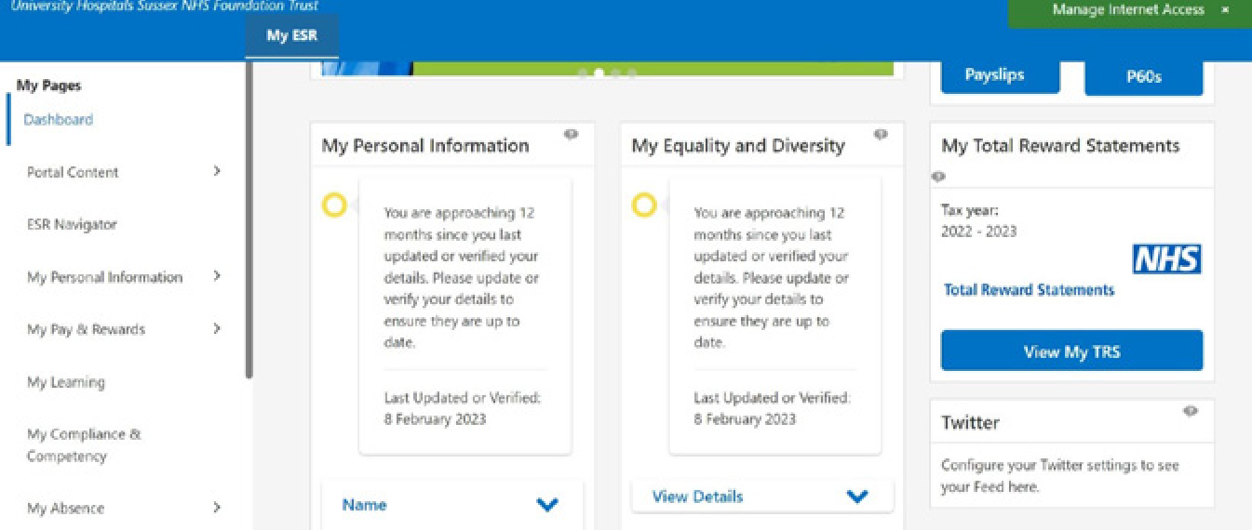
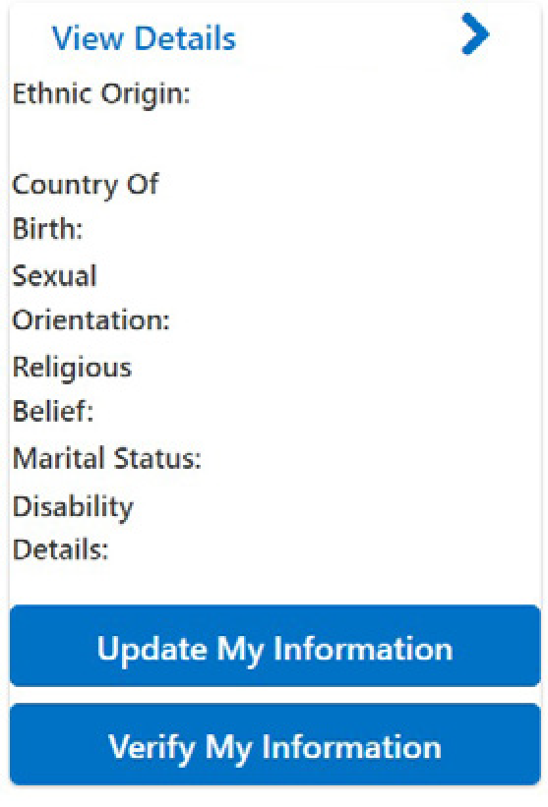

11

Reasonable adjustments
Your line manager may differ from people who give you tasks or roles day-to-day, e.g., shift leaders.
This page should list the reasonable adjustments you require so it can be detached from the passport and shared with the relevant and appropriate staff with your consent.
Please do not include any information you do not wish to share with others.
Managers must ensure this information is stored securely and only share it with staff responsible for allocating the staff member duties in line with their reasonable adjustments.
If you have any questions, please contact the Equality, Diversity and Inclusion Team at uhsussex.equality@nhs.net

12

