
KnowledgeShare Evidence Updates: Amending your Interests
Over time, your professional interests may change or expand. Your library service are always on hand to help you update these, but if you wish, it is possible to do this yourself by logging into KnowledgeShare.

How do I login to KnowledgeShare?

You can log into KnowledgeShare with your NHS OpenAthens account at knowledgeshare.nhs.uk
If you don’t have an NHS OpenAthens account, you can register at openathens.nice.org.uk

How do I edit my professional interest settings?

Once logged in, click on your name in the top right of the screen and click Your Profile. Then click on Edit in the top right of the Professional Interests box.
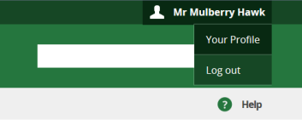
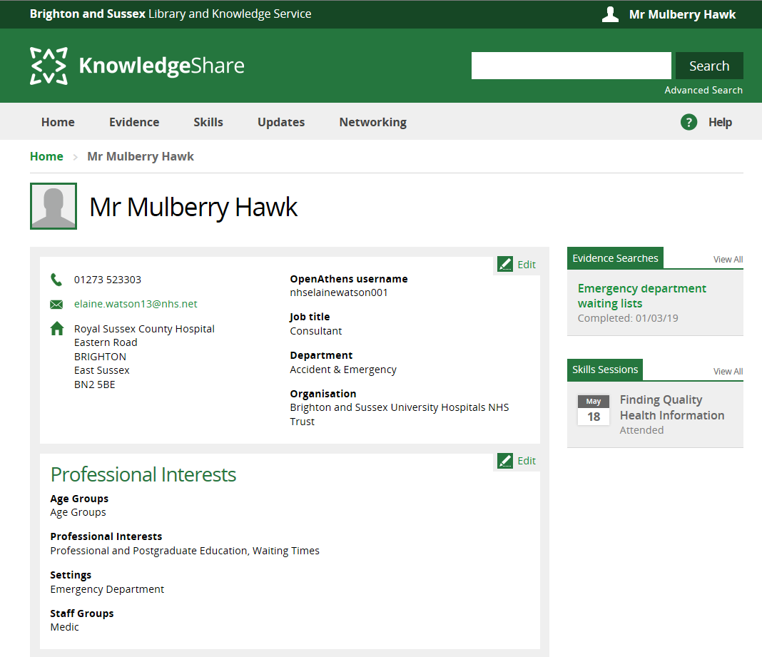

You then have two options: You can either update your profile using the category fields at the bottom of the page, or note your interests in the text box at the top for your library team to review and amend on your behalf.

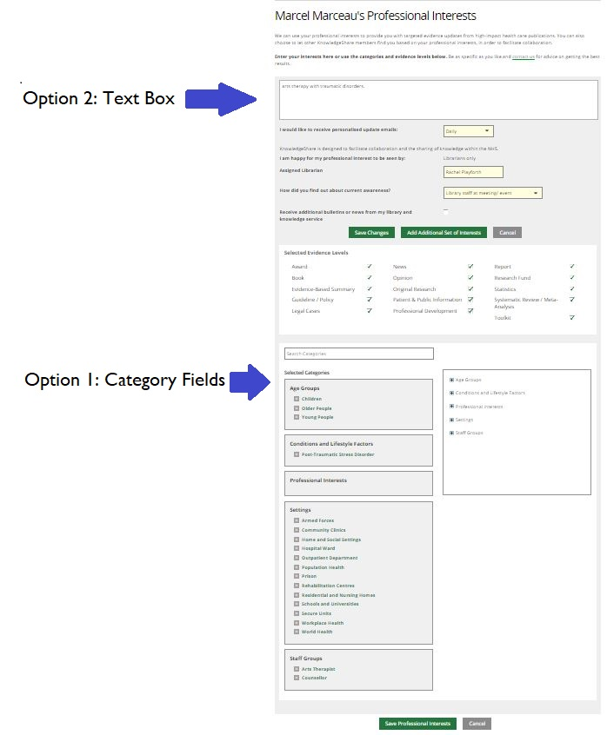

Option 1: Category Fields

If you feel happy to update your settings yourself, use the category fields at the bottom of the page.

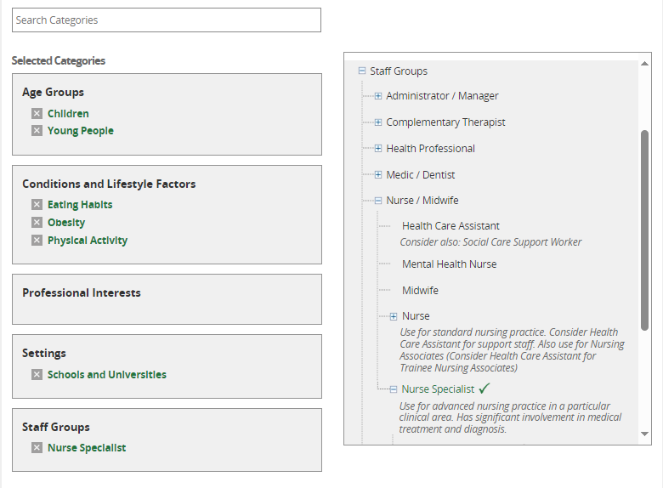
In the right hand field, navigate and select categories to populate the left hand field (You can also use the search bar at the top to locate categories, though remember to clear this with the “x” button that appears in it after each search)

Select the age groups, settings and staff groups that represent your interests, followed by the conditions and lifestyle factors, and/ or professional interests that you want to receive updates on (You must complete the “Conditions and Lifestyle Factors” box and/or the “Professional Interests” boxes to ensure KnowledgeShare filters content effectively)

[NOTE: Your librarian may adjust your categories to optimize your evidence update content]

Option 2: Text Box

The text box at the top of the page allows you to note down your topics of interest for your assigned librarian to review (After clicking “save” they will be notified via email) This option is good if you are unclear on what to add, or would simply feel happier to have your library team do this on your behalf.

Give your librarian information on the clinical or professional topics you are interested in, as well as the type of setting you work in, your job role and relevant age groups of the people you work with. This option requires library staff to make the changes, so allow time for them to review your profile.

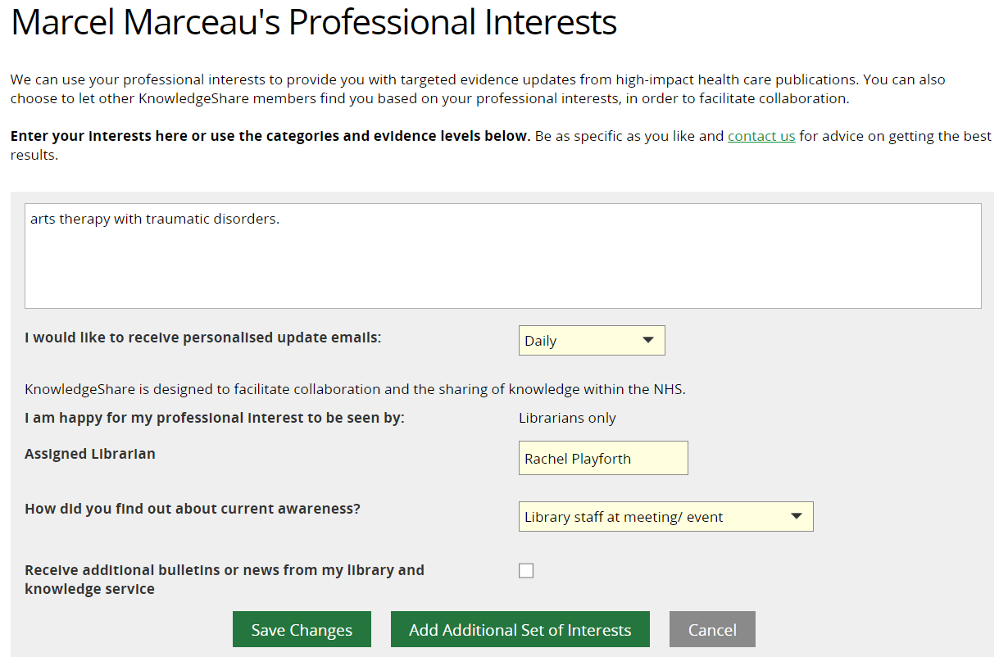

Privacy Policy: We are committed to safeguarding your information. The information you supply will be used to contact you about services or resources you have requested from the Library and Knowledge Service. For further information on how we keep your information secure, and your rights to access it, read the full KnowledgeShare Privacy Policy

