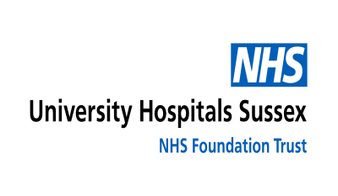
Urine Sample for Schistosomiasis (Bilharzia) Testing
This guide is here to help you collect a urine sample if your doctor has asked for it. This sample is tested in our laboratory to check for schistosomiasis (also known as bilharzia), a parasitic infection that can affect the urinary system or other parts of the body. We aim to make this process simple and stress-free. Please follow these steps carefully to ensure accurate results.

What You Will Need
- A yellow microbiology or ICE request form from your doctor (with your details and the test requested).
- A labelled plastic container (with your surname, forename, date of birth, and/or hospital number). This container has no preservatives.
- Collect the sample between 10am and 2pm on the same day. Important Note: Once collected, bring the sample to the lab as soon as possible to keep it fresh. Delaying could affect the test results.

How to Collect Your Sample
- Start at 10am: Empty your bladder normally and discard the urine (do not collect it).
- Between 10am and 2pm: Collect all urine you pass into the plastic container.
- At 2pm: Try to empty your bladder one last time into the container.
- After collection: Write the date and time of collection on the container and request form. Screw the lid on tightly.

Critical Step: Collect during 10am–2pm time window as the parasites are more likely to be present then. If you miss it, contact your doctor for advice on repeating.

After Collection
Place the container in the clear pouch on the back of the request form. Seal the pouch (use extra tape if needed). Return the sample and form right away to your GP or drop it off at Worthing Hospital or St Richard's Hospital Pathology reception.

Precautions
No special diet or medication changes are needed unless your doctor says otherwise. If you are on your period, wait until it ends or check with your doctor.

Questions or Help
For questions about these instructions, please contact the Medical Microbiology Department at St Richard’s Hospital on 01243 831633.

For questions about your health, treatment, or test results, please contact your GP or hospital doctor. The laboratory is unable to provide medical advice or give test results directly to patients.
We are committed to accessibility. If you need this in large print, Braille, audio, or another language, email: UHSussex.communications@nhs.net or speak to us.

